For Office use only

Date Started ______________ Enrolment Number ____________ Rm______ Records Requested ____

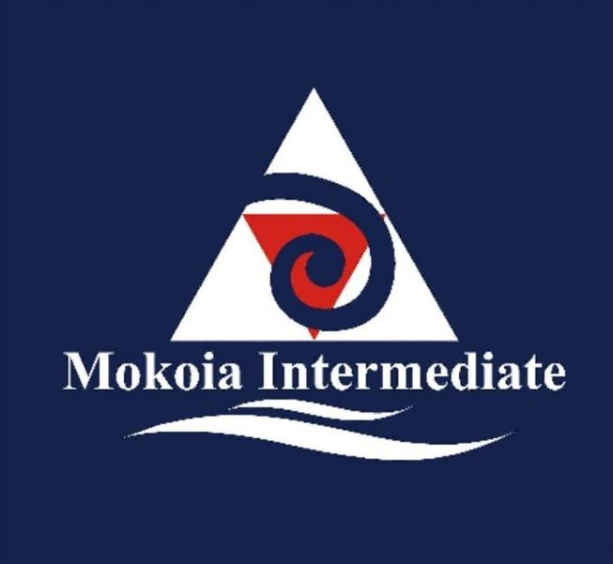 |   Mokoia Intermediate School  Enrolment 2025
The information on this form will be used by Mokoia Intermediate School to maintain effective contact with the enrolled student’s parents/caregivers and for appropriate school records as required by the Ministry of Education.

Student Details
Family name of child: ________________________ First names of child: ____________________________
Preferred first name: _________________________ Gender: ________ Date of birth: ________________
Address of student: _______________________________________________________________________ Mobile No: _________________________________ Home phone: _______________________________
2024 School ___________________­­­­­­­__________________________________________________________

Contact Details of Parents / Guardian with whom the child lives:
- First Contact in an emergency:
Surname: _____________________________ First names: ______________________________________

Work phone: ___________________________ email: ___________________________________________
Relationship to student:_____________________ Occupation/workplace: ___________________________

- Second Contact in an emergency:

Surname: _____________________________ First names: ______________________________________

Address: ________________________________________________________________________________

Mobile No: ___________________Work Phone: ______________ e-mail:____________________________

Relationship to student:_____________________ Occupation/workplace: ___________________________

Other Contact Details
- Other Parent/family members/friend:
Name: ______________________________________________Phone:______________________________
Relationship to child: _____________________________________________________________________
Address: ________________________________________________________________________________
- Other Parent/family members (who are NOT allowed access to the child)
PLEASE SUPPLY COPIES OF COURT PAPERS
Name: ____________________________________________Phone: _________________________
Relationship to child: ______________________________________________________________________
Address: ___________________________________________________________________________
Country of birth: Please circle: New Zealand Other (please state)__________________________ Citizenship: Please circle: NZ citizen NZ permanent resident Other (please state)_______________
Ethnicity:
Student’s ethnicities ____________________________ Student’s iwi affiliations (if appropriate)
Father’s ethnicities______________________________ 1. __________________________
Mother’s ethnicities ____________________________ 2. __________________________

The student’s first language is _____________________________________________________
The language mainly spoken at home is _____________________________________________
If my child is not currently enrolled in a New Zealand school I/we have attached a copy of the student’s birth certificate or relevant passport pages (required by the Ministry of Education) YES (please circle)
Information to Assist in the Placement of Your Child
Please attach any relevant data/information that you wish to share
Special circumstances / Sensitive information eg special needs, support or extension needed, family circumstances, things to be aware of:

________________________________________________________________________________________
________________________________________________________________________________________
________________________________________________________________________________________
________________________________________________________________________________________
________________________________________________________________________________________
________________________________________________________________________________________
________________________________________________________________________________________
________________________________________________________________________________________________________________________________________________________________________________
________________________________________________________________________________________

We try to place each new student with at least one friend. Please give the names of your child’s friends:
- _________________________________________________________________________________
- _________________________________________________________________________________
Do you wish your child to be considered for:
Rumaki Level 1 (81% to 100% Immersion)
Te reo Māori is the main language of communication and instruction.

The main curriculum is taught entirely in Māori.

You may be required to attend an interview to discuss if your child meets the criteria for Level 1 Te Reo
We are a BYOD School
Will your child be bringing their own digital device: Yes / No

Photographs: From time to time photos of groups of students at work may be used in displays in the school or posted on our website as part of articles. No child is ever identified.

I do / do not consent to photos which include my child being displayed
Parent / Caregiver Declaration
I/We acknowledge that the information given is correct and will be relied upon by the school.
I/We agree that our child will abide by school expectations, including the Digital Technology User Agreement
I/We understand that the information supplied will be used by the school to maintain effective contact with the enrolled student’s parents/caregivers and appropriate school records as required by the Ministry of Education.

I/We also agree to the school:
Requesting relevant information from other schools for enrolment purposes and class placements.
Forwarding relevant information to another school for enrolment purposes and class placements.

Generic Field Trip Permission:
I give permission for my child

☐ to take part in Education Outside the Classroom (EOTC) provided by the school.

☐ to travel outside school, using buses, walking or private vehicles for ‘day only’ trips as notified by the Teacher in Charge.

Signature: __________________________ __________________________ Date: / / Parent/Caregiver) (Parent/Caregiver)
Phone: (07) 3459071 email: office@mokoia.school.nz

Please return completed application to the school office

Mokoia Intermediate School
Health Profile

This profile is designed to assist with the care of students at school and on EOTC events.
Child’s Name: ____________________________________________________________________________

1. Please tick if your child has any of the following:

- Migraine  - Diabetes  - Chronic nose bleeds  - Colour blindness  - ADHD | - Epilepsy  - Travel sickness  - Heart condition  - Allergies  - Asthma | - Fits of any type  - Dizzy spells  - Other (Please specify)  ___________________________
For overnight events:

- Anxiety | - Other (Please share concerns with your child's teacher)

Doctor’s Name_________________________________________________ Phone No._________________

2. Does your child take regular medication? YES / NO

The school will only administer prescription medication to students whose parents have made a formal request. Parents/caregivers need to complete a Medicine Authority Form

Is a health plan required? YES / NO (Please provide)

Has your child had any major injuries or illness that may limit full participation in any activities? YES / NO

If YES, please state the injury/illness: ________________________________________________________

Medic Alert Number: _____________________________________________________________________

Details:

3. Is your child allergic to any of the following?

 | YES | NO | Please specify
Prescription medication
Food
Insect bites/stings
Other allergies
What treatment is required?

4. When was your child's last tetanus injection? ________________________________________________________________________________________

5. Is your child fully immunised against Measles, Mumps and Rubella (MMR)? YES/NO
Please provide confirmation from your G.P. if possible

6. Outline any dietary requirements:

________________________________________________________________________________________

________________________________________________________________________________________

7. Can pain medication be given to your child if necessary? (Panadol tablet) YES / NO

8. Is there any information we should know to ensure the physical and emotional safety of your child? (For example cultural practices; disability; anxiety about heights/darkness/small spaces; Family custody requirements; behaviour or emotional problems)
If YES, please state or attach the information: _________________________________________________

________________________________________________________________________________________

________________________________________________________________________________________

________________________________________________________________________________________

Please tick
- I agree that if prescribed medication needs to be administered, a designated adult will be assigned to do this. I will ensure that prescribed medication is clearly labelled, securely fastened and handed to the designated adult with instructions on its administration.
- I will inform the school as soon as possible of any changes in the medical or other circumstances.
- I agree to my child receiving any emergency medical treatment. Any medical costs not covered by ACC will be paid by me. In the case of a medical emergency where no one can be contacted to obtain permission we agree to reimburse expenses incurred to the school.

Parents signature: ______________________________________________ Date: ____________________

Medicine Authority Form

Student’s name
Class teacher
Room
Date:
I request that my child be given the following medication
Time(s) when medicine is given
Procedure for giving medicine
Condition for which medicine is given
Name of prescribing doctor
I accept responsibility for:
- the decision to give this medication to my child, and acknowledge that the school is in no way responsible for that decision, now or in the future
- notifying the school about any changes in dosage, time, or procedures, by filling out a new Medicine Authority form
- delivering the medication personally to school
- ensuring that the medicine is not past its expiry date.

I accept that the school:
- may not have a trained medical officer to administer medications
- cannot guarantee that medication will be given at a precise time or by the same person
- will dispose of any uncollected medicine at the end of the year.
Parent/guardian’s name
Signature
Date

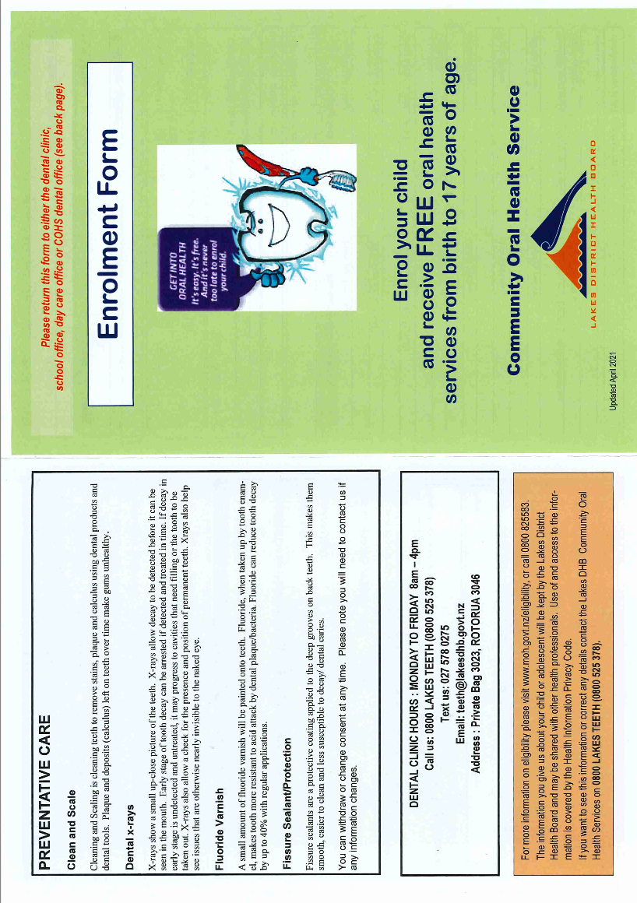

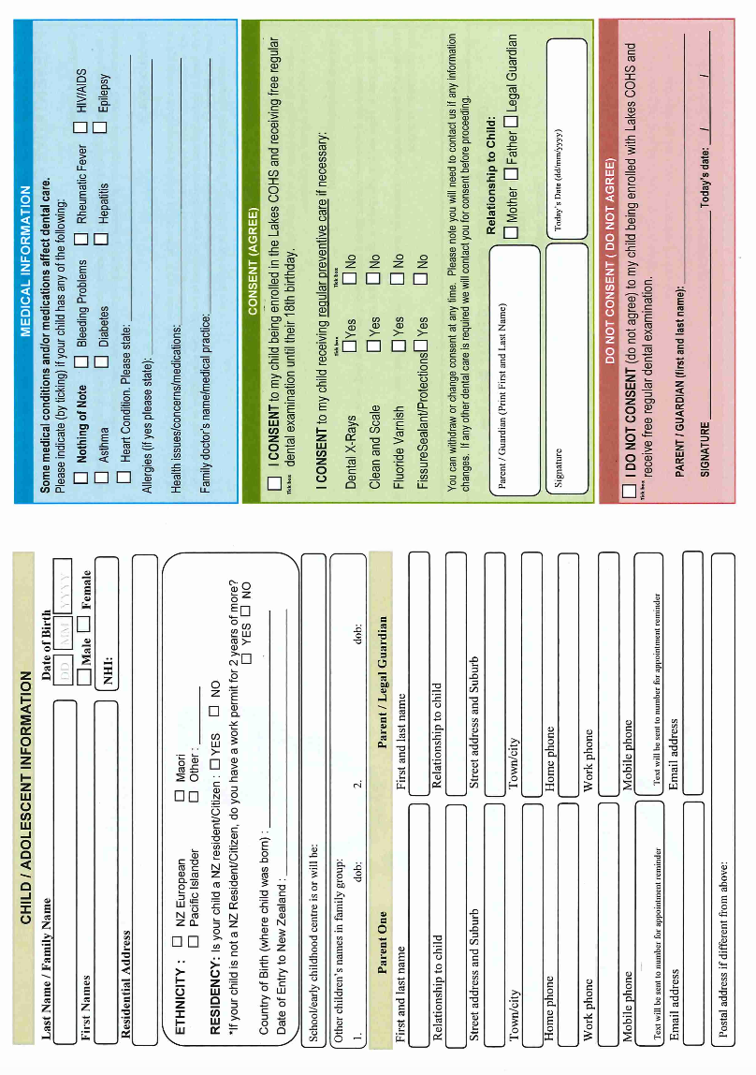

Mokoia Intermediate
Digital Device 2025
Responsible Use Agreement

Access to the Mokoia Intermediate network is a privilege, not a right. Any use of the network entails personal responsibility and compliance with all school rules. Please complete whether you have your own device or use a school device.

The Rights and Responsibilities of Mokoia Intermediate

Mokoia Intermediate is responsible for:
- Providing a strong and reliable computer network that is available to the school community for the purposes of teaching and learning
- Maintaining fast and reliable internet access to its staff and students
- Providing a safe and consistent Internet filtering process that aims to protect all users from misuse as long as the network is used for its intended purposes
- Providing, through learning programmes, the promotion of safe and appropriate use of electronic devices
- Maintaining the ability to monitor activity of users on the network which it will do randomly and periodically
- Maintaining a number of devices for student and staff use at all times
- Providing areas in the school where the device can be safely stored under supervision

Mokoia Intermediate has the right to:
- Expect that a digital device used for learning has a screen size no smaller than 8 inches / 20 centimetres (diagonal measurement). Cell phones are not acceptable; these enable the extra potential of bypassing our filtering by accessing a 3G, 4G or 5G network.
- Install Mobile Device Management software to supervise the device and manage learning apps while at school.
- Randomly and periodically monitor activity of users on the network
- Inspect, on a student’s device, their current school work, mindful that the student’s private content should remain private
- Remove a student’s network access privileges
- Request a student to surrender their device to their teacher, team leader, assistant/deputy principal and/or principal to be returned to a parent/caregiver
- Expect students meet their responsibilities specified in this policy
- In cases of serious breaches of this policy by students, to permanently suspend the student’s use of a device and/or inform appropriate external agencies/authorities, including the New Zealand Police

- Discipline a student by:
- Prohibiting the students from bringing a device to school
- Suspending the student’s use of their device in class
- Suspending the student’s use on the Mokoia Intermediate network

The Rights and Responsibilities of Mokoia Intermediate Teachers

The Teacher is responsible for:
- Working within the school’s responsible use policy
- Ensuring that the teaching and learning provided in their class makes the best use of the available technology, including students accessing learning material and students submitting work
- Maintaining a high standard of behaviour in the class so that all students can access the internet and use their devices safely and to the best educational advantage

The Teacher has the right to:
- Restrict the use of the device in their class when an alternative learning strategy is being used
- Require students to produce handwritten work at any time
- Request the removal of a student’s access to the Mokoia Intermediate network because a student has failed to meet their responsibilities in this agreement

The Rights and Responsibilities of a Mokoia Intermediate Student/Ākonga

The student is responsible for:
- The contents of their own device. If another person uses their device, the owner is responsible for ensuring it is used properly.
- Taking care in looking after their device
- Ensuring their device is fully charged at the beginning of each day
- Keeping the passwords to Mokoia Intermediate’s network and any other programmes secure and private
- Using the device in class for learning as directed by the teacher or in association with the topics and work assigned
- Not using their device or the network inappropriately

A student will have the right to:
- Bring a mobile internet capable device to school
- Store private content on their device and that content will remain private
- Use their device for approved learning during class time and sometimes before school, at breaks and after school when agreed upon by the teacher

The Rights and Responsibilities of the Parent/Caregiver of Mokoia Intermediate Student/Ākonga

The parent or caregiver is responsible for:
- Endeavouring to provide their child with a device
- Discussing the contents and intent of this agreement with their child
- Remaining aware of what their child is doing with their device
- Ensuring their child understands the value of the device and respects it
- Insuring the device
- Notifying the school of any suspected misuse of the device in school time or on the school network
- Recording and storing the serial number of the device
- Having the power charger tested and tagged by an electrician.

The parent/caregiver has the right to:
- Expect that Mokoia Intermediate will provide a strong, reliable and safe computer network that is open to all members of the school community for the purposes of teaching and learning
- Expect that Mokoia Intermediate provides teaching and learning opportunities that make the best use of the device and available technology
- Ask to see work on the device that the student is currently undertaking
- Ask that that the student not bring their device to school
- Query staff about work students are completing on the device

Examples of misusing your right to access the Mokoia Intermediate digital network
- Accessing proxy sites that allow the user to bypass Mokoia Intermediate’s internet security and controls ***
- Should this be in place, deleting the Mobile Device Management software if the device is intended to be used at Mokoia Intermediate
- Accessing, downloading, distributing or publishing offensive material
- Being involved in electronic bullying e.g. obscene, offensive, disrespectful or aggressive language towards others
- Distributing or publishing your own (or anyone else’s) personal details over the Internet or between devices
- Distributing or publishing your own (or anyone else’s) login details
- Sending email “spam”
- Using another person’s log-in details
- Breaching copyright laws. Illegal downloading or sharing files that are protected by copyright
- Downloading and/or installing illegal software or software that you do not own or is not free
- Using a cell phone as a personal hotspot to bypass the need to use the Mokoia Intermediate network

You should also be aware that:
- While at school you are still subject to the school’s internet safety policy which you read and agreed to on enrolment. This applies to school and personal devices.
- You are responsible for the contents of your own device and any activity that is done under your log-in details.
- If permission is granted to another person to use your device it is YOUR responsibility to ensure it is used properly. You will be held responsible.
- Failure to follow the guidelines, and to use your own common sense in judging what is right and what is wrong, will result in suspension of your right to use your device. Serious breaches of this policy will result in the permanent suspension of this right. Other consequences may also likely apply.

Security and Insurance
- The device is your property and as such it is up to you to take due care of it given its expense.
- The school will take no responsibility for loss or damage beyond a normal investigation into an incident involving student discipline.
- The school is NOT insured for your device so insurance is your responsibility.

School Liability Statement
- Students bring their devices to use at Mokoia Intermediate at their own risk. It is their duty to be responsible in the upkeep and protection of their devices.

Mokoia Intermediate is in no way responsible for:
- Personal devices that are broken while at school or during school-based functions
- Personal devices that are lost or stolen at school or during school-based functions
- Maintenance or upkeep of any device (keeping it charged, installing updates or upgrades, fixing any software or hardware issues)

Mokoia Intermediate Digital Device Agreement - School Copy

User Agreement - initial, sign (overleaf) and return
Please review and sign the agreement together with your child. No student will be permitted to use personal technology devices unless the agreement is signed and returned.

Students and parents participating must adhere to the Digital Device Responsible Use Agreement, as well as all Board policies, particularly Internet Acceptable User Policy and Internet Safety Policy. Please read carefully and students need to initial every statement:

- Students take full responsibility for their devices. Personal devices cannot be left at school before or after the school hours.

- Devices cannot be used during assessments, unless otherwise directed by a teacher.

- Students must immediately comply with teachers’ requests to shut down devices or close applications.

- Students are not permitted to transmit or post photographic images/videos of any person on public and/or social networking sites.

- Personal devices must be charged prior to bringing them to school and run off their own batteries while at school. Charging will be available on a limited basis and is up to teacher discretion.

- To ensure appropriate network filters, students will only use the assigned wireless connection in school and will not attempt to bypass the network restrictions by using 3G or 4G network.

- Students understand that bringing devices on premises to infect the network with a virus or programme designed to damage, alter, destroy, or gain access to unauthorised data or information is in violation of the school policy and will result in disciplinary action. The school has the right to collect and examine any device that is suspected of causing problems or is the source of an attack or virus.

- Mokoia Intermediate has the right to inspect content on any device irrespective of whether it has been the cause of a problem/attack/virus (This covers devices that may contain objectionable material obtained offsite and stored on the student owned device).

- It is the owner's responsibility for the repair of any malfunctioning/damaged devices. Mokoia Intermediate does not supply technical services for student owned devices.

- Students should not physically share their personal devices with other students, unless they have written parent permission to do so.

- The use of personal devices to support educational experience is not a necessity but a privilege. With respect of the rules, this privilege will benefit the learning environment as a whole. When rules are abused, privileges will be taken away.

- I understand and will abide by the above policy and guidelines. I further understand that any violation is unethical and may result in the loss of my technology privileges as well as other disciplinary action.

Parents:

All devices brought to school are my son’s or daughter’s responsibility and the insurance for the device is my responsibility. School owned devices must be used as per this responsible use agreement.
My child will be using a personal device brought from home / a school owned device (please circle)

I have read this document and understand the contents and will adhere to each part to maintain privileges.

Printed student name: ______________________________________________

Student signature: ____________________________ Date: ____________

I agree to support my child and the school with each part of this responsible use document.

Printed guardian name: ______________________________________________

Parent/guardian signature: ____________________________ Date: ____________

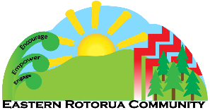Eastern Rotorua Kāhui Ako Learning Support Register Consent Form
Why we are sharing information?
Our school/kura/early childhood centre is part of a group of education providers that shares information to:
- identify children and young people who might need additional learning support
- ensure that the adults who work with children (such as teachers or teacher aides) have the skills and resources they need to support them
- decide what additional learning support would help children and young people, whether individually or in groups
- support with transitions between schools within our Kāhui Ako.
The Ministry of Education may use information on the register for the purpose of administration and analysis, for example to find out about the overall numbers of children requiring specific types of support. This will allow the Ministry to plan ahead for numbers of staff and specialists, and other services and types of support.
What information we will share?
The members of our Eastern Rotorua Community of Learning - Kāhui Ako include: Lynmore Primary School, Owhata School, Rotokawa School, Mokoia Intermediate, Rotorua Lakes High School, STAND, Awhi Educare @ Owhata, BestSTart Lynmore, Central Kids Kindergartens – Owhata, Te Wharewhitinga o te Ra, Central Kids Kindergartens – Rotorua East, Eastern Suburbs Pre-School Inc, Lake Okareka Preschool Education Group, Learning Adventures Rotorua Tui, Ohana Kindy, Rotorua HomeBased Childcare, Stepping Stones Learning Environment, Tiaki Early Learning Centre, along with any new schools/centres who join the Eastern Rotorua Kāhui Ako and the Ministry of Education share information for a collective learning support register that contains:
- name, gender and ethnicity to identify support that reflects the child’s identity, language and culture
- date of birth and year level, to identify support that is appropriate to their age
- the type of support needed
- any health issue, disability or learning difficulty that means a child needs particular types of support
- services and support they are already receiving
If you agree, we will put information about your child’s additional support needs on the Eastern Rotorua Kāhui Ako Learning Support Register.
Who will see the information?
Only a small panel team of people will have access to the register for the purposes explained in the first paragraph. It will include
- a delegated school staff member with responsibility for learning support (e.g. special education needs teacher)
- the delegated Kāhui Ako Coordinator, ECE Leads (for ECE) and Principals
- the Learning Support Coordinators within our Kāhui Ako
- a resource teacher learning and behaviour
- the Kahui Ako delegated MICAMHS clinicians
- the learning support facilitator (Ministry of Education staff member/s)
These people will meet regularly to discuss the register and how best to respond to the needs of children and young people on the register. Others may be contacted should they be supporting the purposes explained in the first paragraph.
How will we keep the information safe?
Any information will be transmitted and stored securely via password protected files, which only authorised people will be able to access.
Information about children and young people no longer enrolled with an education provider in the Eastern Rotorua Kāhui Ako will be removed from the register.
Students no longer needing learning support will be kept on the register and monitored for a time then removed from the group register.

How can you see and correct the information?
You can request access to the information through the school/kura Principal and may correct any inaccuracies.

What will happen if you don’t agree to your child’s information being shared?
If you do not agree to your child’s information being included on the register, we will still provide support for your child’s needs within our school/kura/early learning service. But if your child’s information is not on the register, they may not be able to gain early access to resources provided across the group.

You can decide to withdraw your consent at any time by contacting your school.

----------------------------------------------------------------------------------------------------------------------------------------------

Eastern Rotorua Kāhui Ako Learning Support Register Consent Form
I agree to personal information about my child/ren being included on the register while my child is enrolled in an ECE/School within Rotorua East Kāhui Ako and that information being shared with the group of people listed for the purposes explained above.

Child’s Name _____________________ School______________________

Child’s Name _____________________ School______________________

Child’s Name _____________________ School______________________

Child’s Name _____________________ School______________________

----------------------------------------------------------------------------------------------------------------------------------------------

Parent’s Name _____________________ Caregiver/Guardian: _____________________

Signature__________________________ Date________________________

